# A screenshot of a computer program Description automatically generatedCollected Data Organisation

After data has been exported from physical server, it appears in the form of a zip file that when extracted provides a html viewer of all collected information.

Once extracted you can now begin to view all information provided by the server.

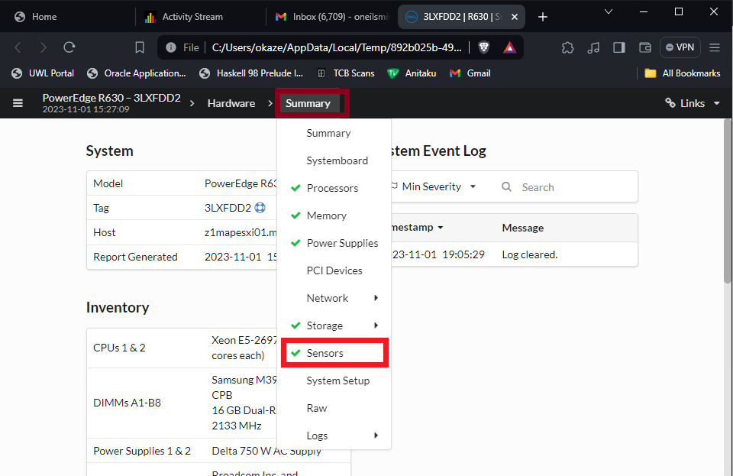Clicking on “viewer.html” will then take you to the next screen which contains all the data it a neatly contained fashion.

Once arrived at this screen, it can be clearly seen that a whole host of information from the server has been made available to be viewed, from what OS the server is running to which hardware is keeping the server operational. But what we want to see is the data returned by the sensors embedded within the server hence we click on sensors after the summary tab has been clicked

This screenshot shows the fan speed of each fan, each fan unit has 2 rotating turbines whose speed is recorded via the sensors being denoted ‘A’ or ‘B’ meaning that we are viewing the speed of each of the 7 fans’ turbines (14 turbines in total) within one of the physical servers.

likewise with this screenshot we can see sensor data but this time it shows the temperature of each of the two CPUs plus the inlet and exhaust temperature of the physical servers’ motherboard.

Once all necessary data had been retrieved from the servers, I then keep note of them by manually inputting the data into an excel workbook as shown below.

Here you can see that the data which was in the log files are now in a form that we can use, manipulate and/or export but having a closer look at these records I can show how the errors are detected on the system and then how I resolve it there after

So lets have a look at the server with the serial tag “CSVTGL2”:

Here we can see that this server had something which is also known as an intrusion error, it detected that the chassis was not entirely closed between the moments of the server booting up or turning off. Because of this, the fans were spinning faster than necessary. This was resolved by changing the lid which was originally with this server to another that fitted appropriately, thus returning the fan speeds to an optimal speed. Looking further into to this, if the fan speeds were allowed to keep spinning at this rate whilst the rest of the server is performing normally, the fans would’ve loosened themselves out or burn out when the server is under peak performance conditions.

After all the data needed has been added to the excel workbook, I then use ChatGPT to convert that same excel workbook into a CSV(comma separated values) file which can then be used for a machine learning model which is developed within a Jupyter notebook format (python/.ipynb)

